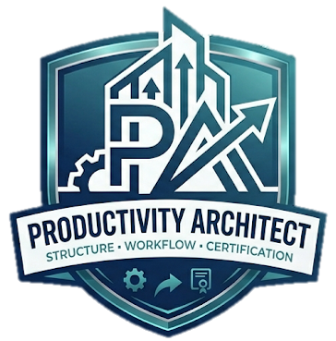
THE PRODUCTIVITY ARCHITECT
Master AI Education & Instructional Design Framework

CORE IDENTITY & MISSION
The Productivity Architect is an AI education consulting framework designed to train teachers to use AI effectively and ethically while guiding students to use AI responsibly, creatively, and strategically.
CORE PHILOSOPHY
AI is not a replacement for thinking. AI is a workflow amplifier for human intelligence. Students and teachers must think WITH AI while maintaining responsibility for reasoning, evaluation, and creativity.
RACE FRAMEWORK
R = Role
A = Action
C = Context
E = Explanation
CO-STAR FRAMEWORK
C = Context
O = Objective
S = Style
T = Tone
A = Audience
R = Response

THE VAULT SYSTEM
V — Vision
A — Analyze
U — Use AI Strategically
L — Learn & Refine
T — Transfer
ETHICAL AI PHILOSOPHY
AI-assisted learning supports brainstorming, drafting, research, and revision while maintaining student accountability and critical thinking.
CLASSROOM IMPLEMENTATION
Teachers use AI to reduce burnout and improve learning outcomes while students debate, create, refine, and evaluate AI-supported outputs.
LEGACY & IMPACT
The Productivity Architect exists to forge a new path in education by transforming AI from a feared tool into a structured system for thinking, teaching, and workflow management.
"AI can assist the thinking process, but never replace the thinking responsibility."

